Assignment 1 Program – User Manual

Due date: 14th August, 2019.

The application in written in C# and .NET using visual studio IDE. When the program launches it asks for the name of the user, the number of months they are supposed to be registered and whether they are to earn any special offers. The number of months should be strictly a positive integer between 1 to 60. When the user enters a value that not a sting a warning indicating that only string values pops up for the user in the command prompt and the user input information opens up with appropriate information. When the user enters a value less more than the bound specified a user warning appear and user input interface appears to take users input.

The taking of user interface happens as a set and takes M number customers information. For our case M is equal to 9. After every customer input the program calculates the amount they are to pay. Then after M number customers have been entered the program calculates the stuffs like high spending users, lowest spending users, number of months below six months and customers above six months and a chart showing all the information gathered and all the calculations.

Program Output.
Case 1: Correct Customer Input:
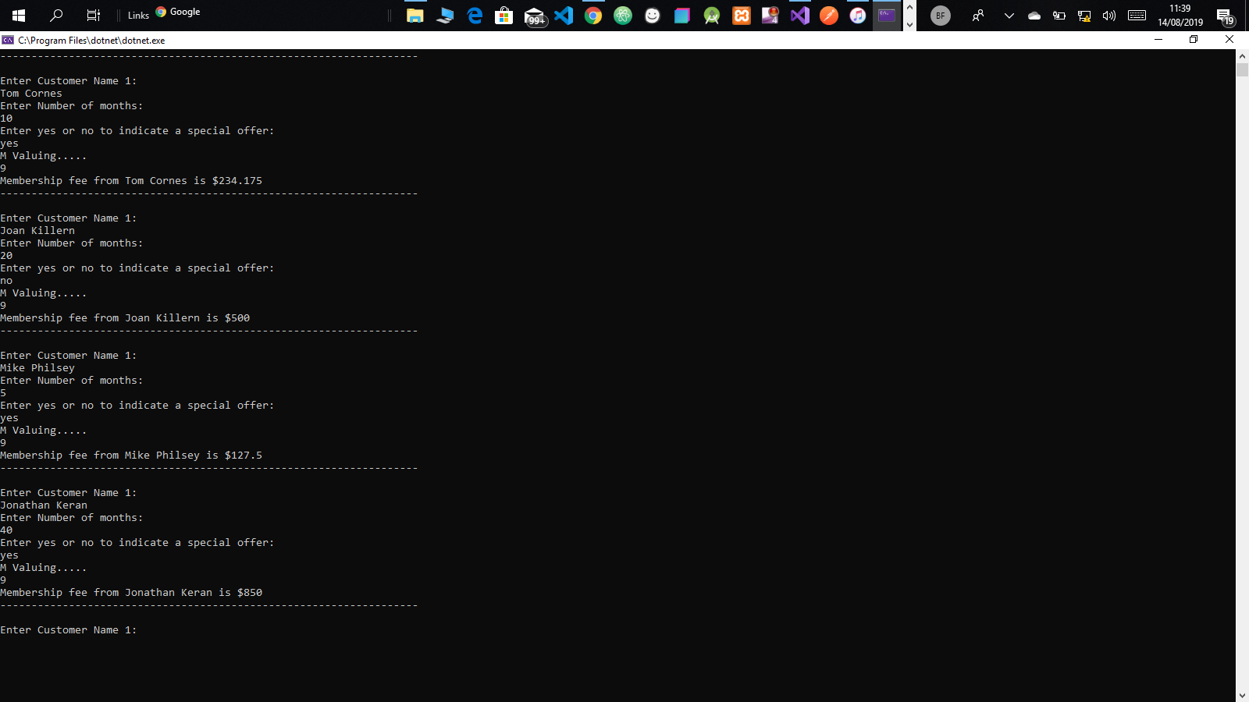
This case clearly shows that after every user input and takes user input 9 times while calculating Membership fee they will be paying. This is done for each member.

Case 2: Calculation based on each set of Customers.
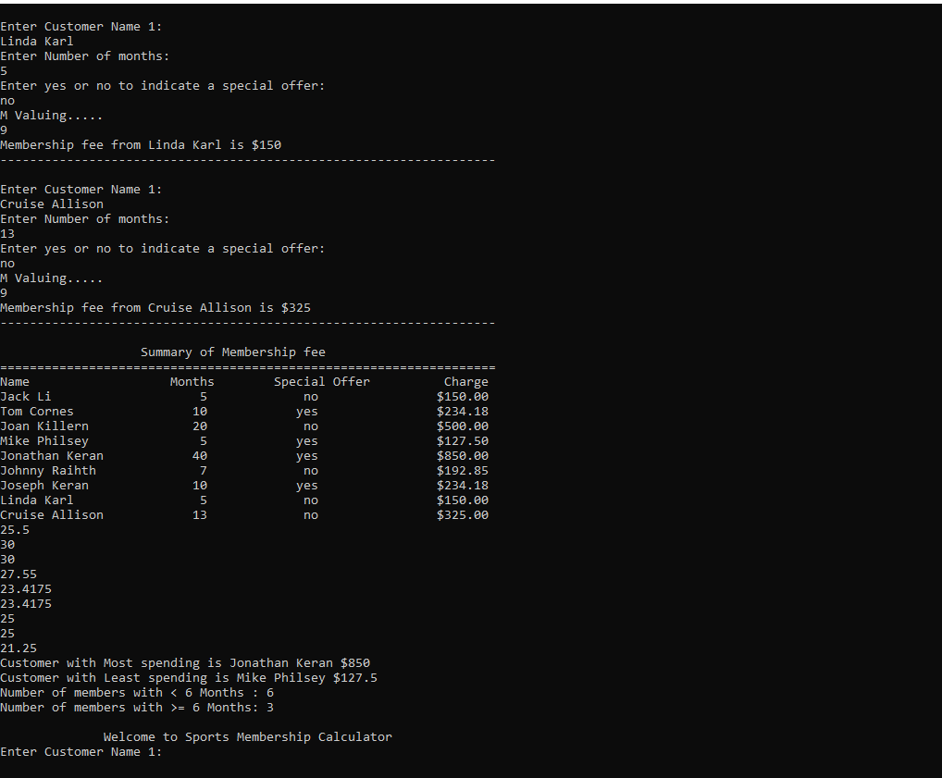

This case shows calculation of For the fee charges for every member the number of months they are to carter for and whether there is a special offer for them or not. The highest paying individual is also taken into account and the least paying individual. The number of members paying for more than six months is also taken into account and also members with less than six months are taken into account.

Case 3: Errors.
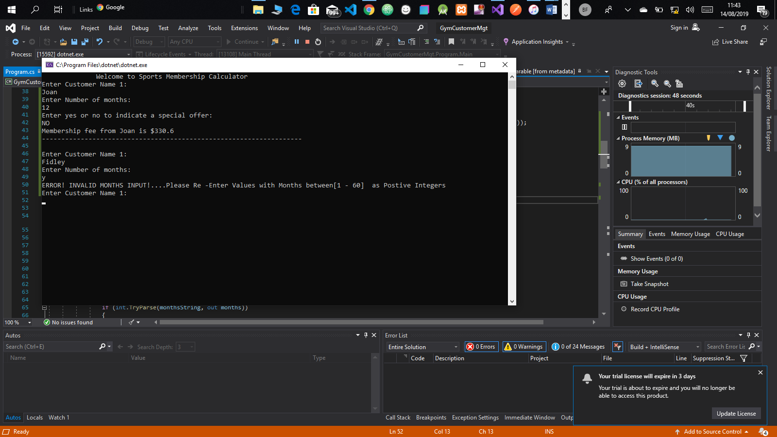

This case indicates all types of errors that the system encounters and covers for. When the users enters months more than 60, an error pops up, when the system expects an integer and user enters a non-integer value, the system warns the user

